Albert Town High School Mathematics Department

Mathematics Practice Paper

Based on CSEC May 2009

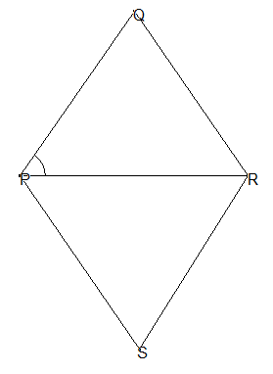

1. (a) Using a calculator calculate the exact value of
   1.  giving your answer as a common fraction
   2. giving your answer in standard form
   3. The basic wage earned by a truck driver for a 40 hour week is $560.00
      1. Calculate his hourly rate
      2. For overtime work the driver is paid at one and a half times the basic rate. Calculate his overtime wage for 10 hours of overtime
      3. Calculate the total wage earned for a 55 hour week
2. Factorize completely
   1. 
   2. 
   3. 
   4. One packet of biscuits costs $***x*** and one cup of ice cream costs $***y***. One packet of biscuits and two cups of ice cream costs $8.00 while three packets of biscuits and one cup of ice cream costs $9.00
      1. Write a pair of simultaneous equations to represent the information given above
      2. By solving the equations find the cost of one cup of ice cream and one packet of biscuits
3. In a survey of 50 students

23 owned cellular phones

18 owned digital cameras

***x*** owned cellular phones and digital cameras

2***x*** owned neither

C D

1. Copy and complete the Venn diagram below
2. Write an expression in ***x*** for the total number of students in the survey
3. Calculate the value of ***x***

b.

600

6 cm

Using a ruler, compass and a pair of compasses only construct the Rhombus PQRS with PR = 6cm and angle PRQ = 600.

Measure and state the length of QS

1. Given that  and 
2. 
3. 
4. 

b. Given that 

(i) Copy and complete the table below

|  |  |  |  |  |  |  |  |
| --- | --- | --- | --- | --- | --- | --- | --- |
| X | - 4 | - 3 | - 2 | - 1 | 0 | 1 | 2 |
| Y | 5 |  | -3 | -4 | -3 |  | 5 |

Using a scale of 2cm to represent 1 unit on the ***x*** – axis and 1 cm to 1 unit on the ***y*** axis plot the graph of  for 

1. Solve the following pair of simultaneous equations
   1. 
   2. Express  in the form where are real numbers
   3. Using your answer or otherwise calculate
      1. The minimum value of 
      2. The value of x for which the minimum occurs
   4. Sketch the graph of  clearly showing
      1. The coordinates of the minimum point
      2. The value of the ***y*** intercept
      3. The values of x where the graph cuts the ***x*** axis
   5. Sketch on your graph of the line which intersects the curve at the values of ***x*** and ***y*** calculated in part a
2. 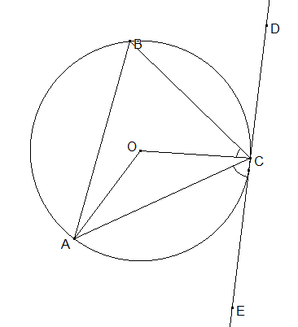The diagram below [not drawn to scale] shows a circle with center O. The line EDC is a tangent. Angle ACE = 480 and angle OCB = 260.

Calculate the following angles

* + 1. ABC
    2. AOC
    3. BCD
    4. BAC
    5. OAC
    6. OAB

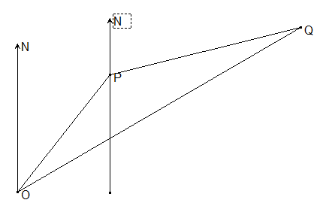The diagram below shows the positions of two hurricane tracking stations, P and Q relative to a point O. P is on a bearing of 0250 from O and OP = 400km. Q is on a bearing of 0800 from P and PQ = 700km

1. Copy and complete the diagram indicating the bearings 0250 and 0800.
2. Calculate
   1. Angle OPQ
   2. The length to the nearest kilometer of OQ
   3. The bearing of Q from O
3. The points A and B have position vectors  and  where O is the origin. The point G lies on the line AB such that . Express in the form 
   1. The vectors  and 
   2. The position vector 

In the diagram below B is the midpoint of OX, C is the midpoint of AB and D is such that OD = 2DA the vectors ***a*** and ***b*** are such that and 

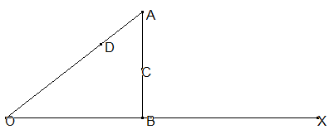

1. Write in terms of ***a*** and ***b***
   1. 
   2. 
   3. 
   4. 
2. State two geometrical relationships between DX and DC
3. State one geometric relationship between the points D,C, and X
4. The value of the determinant of is 13. Calculate the value of x
   1. The transformation R is represented by  and the transformation S is represented by 
   2. Write a single matrix in the form  to represent the combined transformation S followed by R
   3. Calculate the image of the point 
   4. The matrix 
      1. Determine the inverse of N
      2. Hence calculate the value of ***x*** and ***y*** for which 